Water Budget Pre-Post 2011-2012 – Version A

Please put your initials (not your full name) in the boxes.
Date ________________ | First | Middle | Last
LTER Site ____________________

Survey Questions for Teacher Version
If you are a new teacher to the water strand, you can skip questions 1, 2, & 3.

- For the Water Teaching Experiment (TE), please mark the best answer:
  - I didn’t teach the Water TE at all
  - I taught only a small part of the Water TE
  - I taught much of the Water TE
  - I taught the entire Water TE unit

- For the Water Teaching Experiment (TE), please mark all that apply
  - I participated in professional development for the Water TE during the Summer workshop
  - I participated in professional development for the Water TE during school year workshops
  - I received help from project personnel in planning my implementation of the Water TE
  - I received help from project personnel during my implementation of the Water TE
  - I completed the Water TE Teaching Log

- How many times have you taught the water teaching experiment?

All teachers please answer question #4.
- How many years have you been involved in the MSP project?

Pie Chart Questions
The pie chart below describes where water goes on your school grounds when it rains.
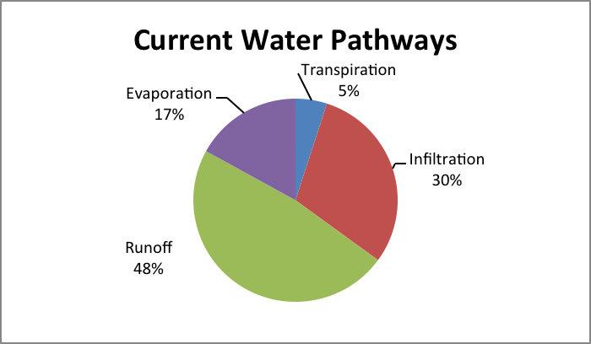

- Your school is considering replacing part of the school parking lot with an open space of grass and trees. Before the decision is made to do this, however, the potential impacts of this change on the water budget have to be considered. Which of the pie charts below best fits the change that would be most likely?

A | 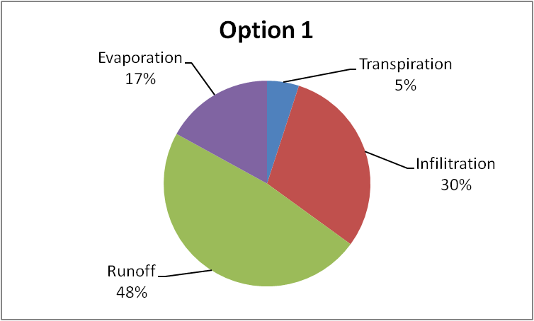 | C | 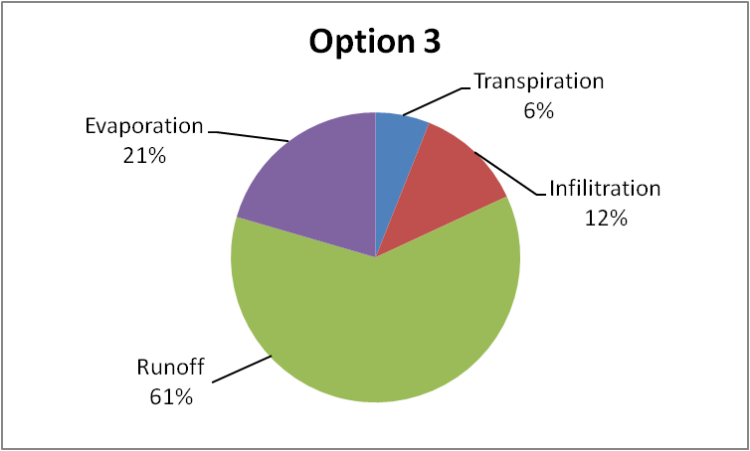
B | 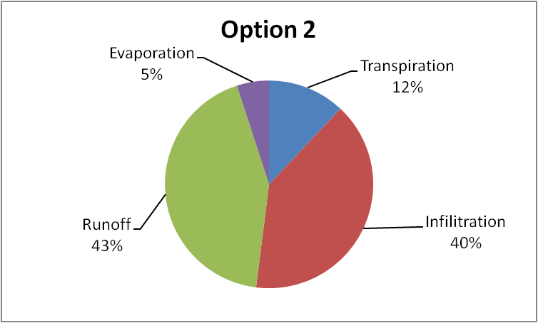

- Please explain what happened to the amounts of infiltration and runoff. Include the reasons why.

- Please explain what happened to the amounts of evaporation and transpiration. Include the reasons why.

Soccer Game Questions
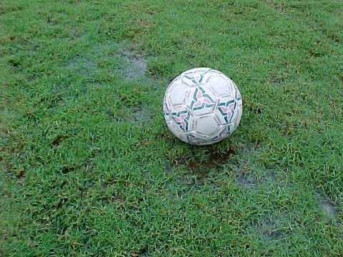
Your soccer game gets canceled at half time due to a massive down pouring of rain. As you run for cover, you notice that there are large puddles forming on the grass covered playing field, but no puddles forming in the sand covered playground just a few steps away.

- Where could the water landing on the sandy playground be going?

- How does the water on the sandy playground get to where it’s going?

- The next week you come back to the soccer field and you notice there is no water on the grassy field. What happened to that water?

River Map Questions
Use the map below to answer questions 7 and 8.
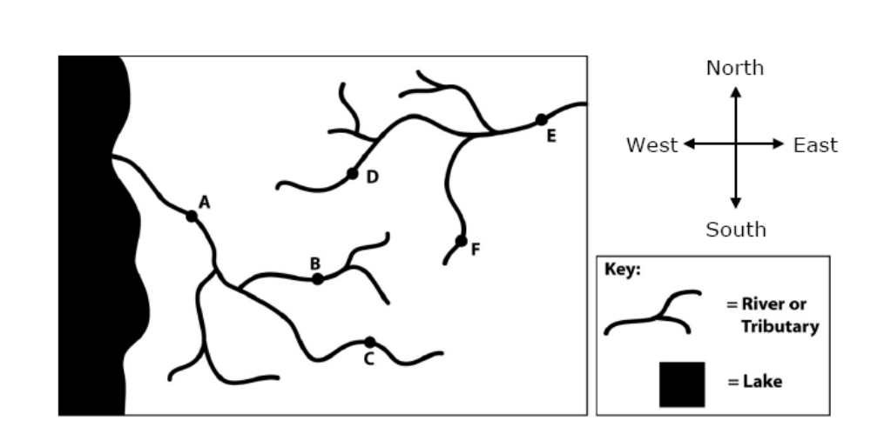

- Can pollution in the river water at point B get to point C? (circle one) Yes No
Explain why or why not.

- Draw an arrow showing the direction water is flowing away from point F. How do you know the water is flowing this direction?

Substances Questions
The picture below shows part of a school campus with several grassy playing fields near a river. Use the picture to answer questions 9, 10, and 11.
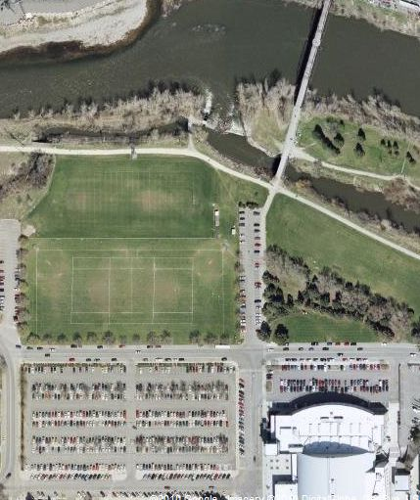

- A. If the playing fields were treated with fertilizer, do you think that some of the fertilizer could get into the river?
(Circle one) YES NO
If you think yes, describe how fertilizer could get into the river. If you think no, describe why fertilizer would not get into the river.
- What is in the fertilizer that could get in the river? (In other words, what is fertilizer made of?)

- If some of the fertilizer got into the river, how would the fertilizer affect the river water and living things in the river?

Tree Questions
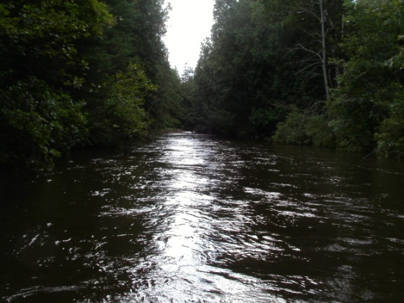
Like many rivers, the Sturgeon River in northern Michigan has lots of large trees growing along its banks.

- What would happen to the amount of water in the river if all of the trees died or were cut down? Be sure to give reasons for your answer.

- A large tree can use 200 gallons of water a day. What happens to those 200 gallons? Please fill in the table below.
List one place the water could go and explain how it gets there. | How much of the water that the tree uses would go there?  All Most  Half A little
List a second place the water could go and explain how it gets there. | How much of the water that the tree uses would go there? (all, most, half, a little)  All Most  Half A little
List a third place the water could go and explain how it gets there. | How much of the water that the tree uses would go there? (all, most, half, a little)  All Most  Half A little

Engineered Systems
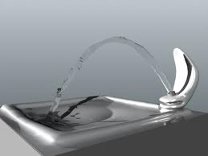

- Where does the water that is used in your school come from? Please explain how it gets to your school. Trace back as many steps as you can.

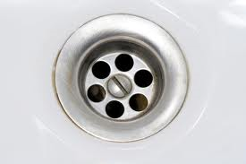
- Where does the waste water from your school go? Please explain how it gets to where it is going. Trace forward as many steps as you can.

